SIMATS ENGINEERING
ASSESSMENT TOOL 1 - Constraint Based Problem Solving

COURSE NAME: STATISTICS WITH R PROGRAMMING COURSE CODE: ITA0407

COURSE OUTCOME COVERED

CO 1: Apply R programming fundamentals including data structures, vectors, matrices, arrays, and class types to perform mathematical operations and manage data effectively.
(Bloom Level -BL2- BL4)

Assessment Tool Weightage: 20%

QUESTIONS: Total Marks: 100

Constraint-Based Problem Solving

1. Student Performance Analysis
A college maintains the marks of 10 students in Mathematics, Physics, and Chemistry. Develop an R program using a matrix while ensuring that marks are within the range of 0 to 100 and handling cases where multiple students obtain the same highest or lowest marks.
(a) Store the marks of the students in an appropriately labelled matrix and calculate the subject-wise average marks.
(b) Identify the highest and lowest scorer in each subject, considering cases where more than one student has the same marks.
(c) Calculate the overall average marks and display the students whose average is greater than the overall average.

2. Employee Salary Processing
An organization maintains employee information including Employee ID, Name, Basic Pay, and Allowance. Develop an R program using suitable data structures while ensuring that Employee IDs are unique and salary components are non-negative.
(a) Calculate the Gross Salary of each employee as Basic Pay + Allowance.
(b) Identify employees whose Gross Salary is greater than ₹50,000 and display the employee or employees having the highest salary.
(c) Generate a summary report containing the total number of employees, average salary, highest salary, and number of employees earning above ₹50,000.

3. Weather Data Analysis Using Arrays
A weather monitoring system records the daily temperature of three cities for seven days. Develop an R program using a 3-dimensional array while ensuring that temperature values remain within the range of -10°C to 50°C.
(a) Store the temperature data in a 3-dimensional array and calculate the average temperature for each city.
(b) Identify the city and day on which the highest temperature was recorded, including all locations in case of a tie.
(c) Compare the temperature variation among the cities using their minimum, maximum, and average temperatures.

4. Product Inventory Management
A retail store maintains Product ID, Product Name, Quantity, and Price using lists and vectors. Develop an R program while ensuring that Product IDs are unique and quantity and price values are non-negative.
(a) Calculate the inventory value of each product using Quantity × Price.
(b) Identify and display all products whose stock quantity is below a specified threshold value.
(c) Generate a stock summary containing the total number of products, total available quantity, and total inventory value.

5. Bank Account Processing Using Functions
A bank requires an account processing system that performs deposit, withdrawal, balance checking, and transaction history operations using user-defined functions. Deposit and withdrawal amounts must be positive, and a withdrawal cannot exceed the available balance.
(a) Develop separate R functions for depositing and withdrawing money while ensuring that invalid transactions do not modify the account balance.
(b) Develop a function to check and display the current account balance after every successful transaction.
(c) Maintain and display a transaction history containing the transaction type, transaction amount, and balance after each successful transaction.

6. Hospital Patient Data Analysis
A hospital maintains patient information including Age, Gender, and Treatment Cost in an R data frame. The system must ensure that age and treatment cost contain valid non-negative values and that missing data is handled appropriately.
(a) Store the patient information in a data frame and calculate the average treatment cost for valid patient records.
(b) Identify and display patients whose age is greater than 60 years while appropriately handling missing age values.
(c) Generate statistical summaries for patient age and treatment cost and identify missing or invalid observations.

7. Logical Vector-Based Voting Eligibility System
A civic organization maintains the Name and Age of citizens and wants to determine voting eligibility using logical vectors. A citizen is eligible only when the age is at least 18 years, while missing age information must be handled separately.
(a) Create a logical vector to determine the voting eligibility status of each citizen based on the age constraint.
(b) Count and display the number of eligible and ineligible citizens while handling missing age values appropriately.
(c) Calculate the percentage of eligible voters among citizens having valid age information.

8. Matrix-Based Sales Analysis
A company records monthly sales of four products across three regions using a matrix. Sales values must be non-negative, and the program must handle cases where multiple products or regions have the same maximum sales.
(a) Store the sales information in a properly labelled matrix and calculate the total sales for each region and product.
(b) Identify the best-performing product based on total sales and display all products if a tie occurs.
(c) Identify the region with maximum sales and generate a summary containing total sales and average sales.

9. Library Management Using S3 Class
A library wants to manage book information using an S3 class named Book, containing Book ID, Title, Author, and Number of Copies. Book IDs must be unique, and the number of available copies must never become negative.
(a) Create the S3 class and implement a method to display complete book details.
(b) Develop a method to update the number of available copies while preventing values that result in a negative number of copies.
(c) Develop a search operation to locate a book using Book ID or Title and display an appropriate message when no matching book is found.

10. University Information System Using S4 Class and Reference Class
A university wants to develop a student information system using an S4 class named Student with Roll Number, Name, and CGPA, along with a Reference Class for managing student records. Roll Numbers must be unique and CGPA values must remain within the range of 0 to 10.
(a) Create the S4 Student class and develop a mechanism to add new student records while preventing duplicate Roll Numbers.
(b) Develop an operation to modify the CGPA of an existing student while rejecting invalid CGPA values and display the updated student details.
(c) Find and display all students whose CGPA is greater than 8.0, and display an appropriate message when no student satisfies the condition.

Code of Conduct:

I __________K Subashree(192521396)__________ (Name / Reg No) certify that this submission is my original work and that I have adhered to the guidelines specified for this assessment.
I understand that any violation of academic integrity rules will result in disciplinary action.

Signature of the student:
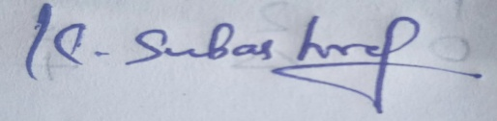

ANSWERS

Constraint-Based Problem Solving Answers
1.CODING
# Create marks matrix (10 students × 3 subjects)
marks <- matrix(c(78,65,90,85,70,95,88,76,92,80,
67,72,85,90,60,88,75,70,82,77,
80,85,78,92,74,89,91,68,84,79),
nrow=10, ncol=3, byrow=TRUE,
dimnames=list(paste("Student",1:10),
c("Math","Physics","Chemistry")))

# (a) Subject-wise average
colMeans(marks)

# (b) Highest & lowest scorers per subject
apply(marks, 2, function(x) {
list(max=which(x==max(x)), min=which(x==min(x)))
})

# (c) Overall average & students above it
overall_avg <- mean(rowMeans(marks))
which(rowMeans(marks) > overall_avg)

OUTPUT
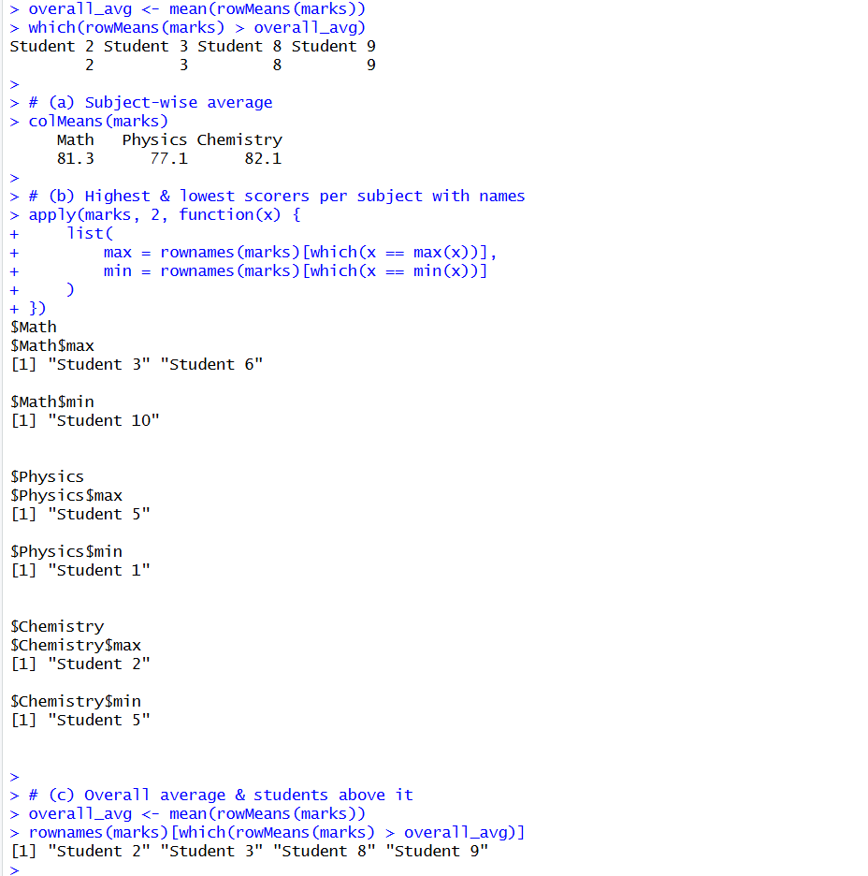

2.CODING
employee <- data.frame(
ID = 1:5,
Name = c("Arun","Bala","Chitra","Deepa","Eshan"),
Basic = c(30000,40000,25000,60000,45000),
Allowance = c(10000,15000,8000,20000,12000)
)
# (a) Gross Salary
employee$Gross <- employee$Basic + employee$Allowance
# (b) Employees > 50000 and highest salary
subset(employee, Gross > 50000)
employee[employee$Gross == max(employee$Gross), ]
# (c) Summary report
list(
TotalEmployees = nrow(employee),
AvgSalary = mean(employee$Gross),
HighestSalary = max(employee$Gross),
Above50k = sum(employee$Gross > 50000)
)

OUTPUT
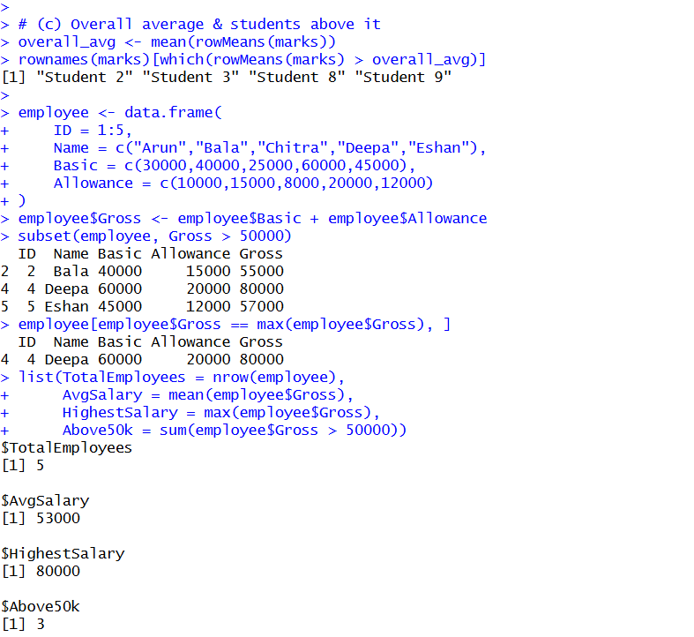

3.CODING
temps <- array(sample(-10:50, 21, replace=TRUE),
dim=c(7,3,1),
dimnames=list(paste("Day",1:7),
c("CityA","CityB","CityC"),
NULL))

# (a) Average per city
colMeans(temps[,,1])

# (b) Highest temperature (city & day)
which(temps[,,1] == max(temps[,,1)), arr.ind=TRUE)

# (c) Variation per city
apply(temps[,,1], 2, function(x) c(min=min(x), max=max(x), avg=mean(x)))

OUTPUT
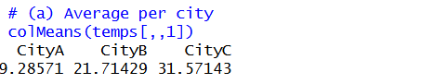
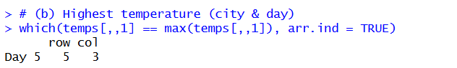
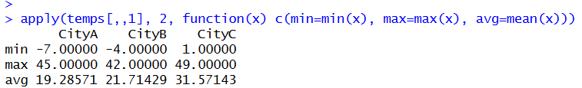

4.CODING

products <- data.frame(
ID = 1:4,
Name = c("Pen","Book","Bag","Bottle"),
Qty = c(50,20,15,5),
Price = c(10,200,500,100)
)
products$Value <- products$Qty * products$Price
subset(products, Qty < 10)
list(TotalProducts = nrow(products),
TotalQty = sum(products$Qty),
TotalValue = sum(products$Value))

OUTPUT
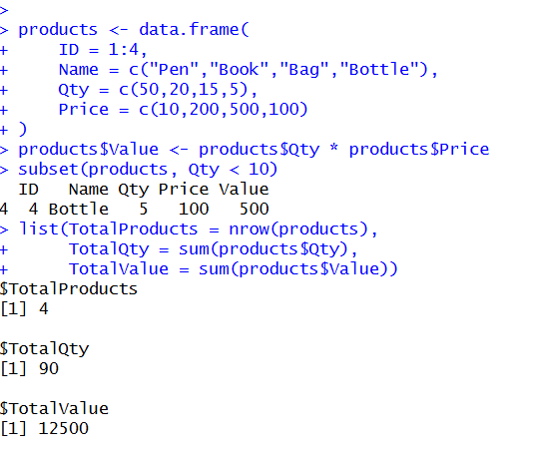

5.CODING
account <- list(balance=0, history=data.frame(Type=character(), Amount=numeric(), Balance=numeric()))
deposit <- function(acc, amt) {
if(amt > 0) {
acc$balance <- acc$balance + amt
acc$history <- rbind(acc$history, data.frame(Type="Deposit", Amount=amt, Balance=acc$balance))
}
acc
}
withdraw <- function(acc, amt) {
if(amt > 0 && amt <= acc$balance) {
acc$balance <- acc$balance - amt
acc$history <- rbind(acc$history, data.frame(Type="Withdraw", Amount=amt, Balance=acc$balance))
}
acc
}
checkBalance <- function(acc) acc$balance

OUTPUT
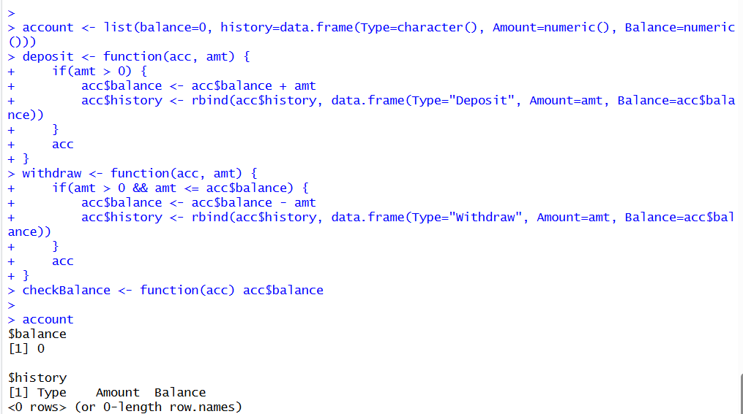

6.CODING
patients <- data.frame(
Age = c(45, NA, 70, 30, 65),
Gender = c("M","F","M","F","F"),
Cost = c(2000, 3000, NA, 1500, 4000)
)
mean(patients$Cost, na.rm=TRUE)
subset(patients, Age > 60)
summary(patients)

OUTPUT
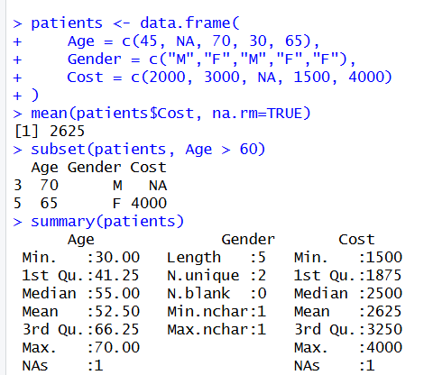

7.CODING
citizens <- data.frame(Name=c("Arun","Bala","Chitra","Deepa"),
Age=c(17,18,NA,25))
eligible <- !is.na(citizens$Age) & citizens$Age >= 18
eligible
table(eligible, useNA="ifany")
valid <- !is.na(citizens$Age)
mean(eligible[valid]) * 100

OUTPUT

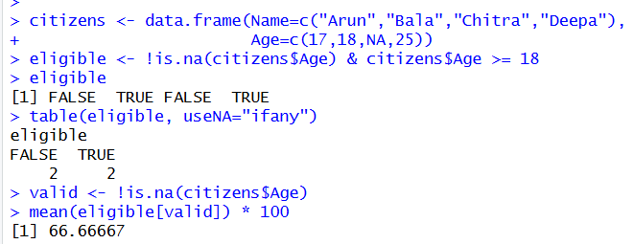

8.CODING
sales <- matrix(c(100,200,150,300,
250,180,220,400,
300,350,280,500),
nrow=3, byrow=TRUE,
dimnames=list(c("Region1","Region2","Region3"),
c("ProdA","ProdB","ProdC","ProdD")))
rowSums(sales)
colSums(sales)
which(colSums(sales) == max(colSums(sales)))
which(rowSums(sales) == max(rowSums(sales)))
list(Total=sum(sales), Avg=mean(sales))

OUTPUT

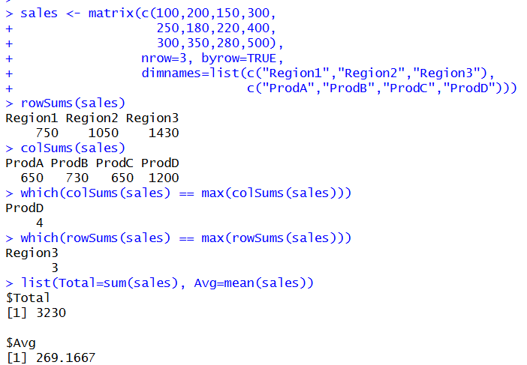

9.CODING
Book <- function(id, title, author, copies) {
structure(list(ID=id, Title=title, Author=author, Copies=copies), class="Book")
}
print.Book <- function(b) {
cat("Book:", b$Title, "by", b$Author, "- Copies:", b$Copies, "\n")
}
updateCopies <- function(b, n) {
if(n >= 0) b$Copies <- n else cat("Invalid copies\n")
b
}
searchBook <- function(lib, key) {
res <- Filter(function(b) b$ID==key || b$Title==key, lib)
if(length(res)==0) cat("No match found\n") else lapply(res, print)
}

OUTPUT

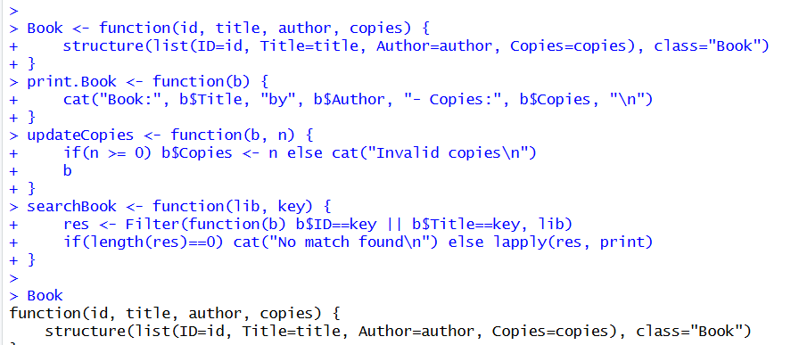

10. CODING

setClass("Student",
slots=list(Roll="numeric", Name="character", CGPA="numeric"))
StudentRecords <- setRefClass("StudentRecords",
fields=list(records="list"),
methods=list(
addStudent=function(roll,name,cgpa) {
if(any(sapply(records, function(x) x@Roll)==roll)) stop("Duplicate Roll")
if(cgpa<0 || cgpa>10) stop("Invalid CGPA")
records <<- c(records, new("Student", Roll=roll, Name=name, CGPA=cgpa))
},
updateCGPA=function(roll,newcgpa) {
if(newcgpa<0 || newcgpa>10) stop("Invalid CGPA")
for(i in seq_along(records)) {
if(records[[i]]@Roll==roll) records[[i]]@CGPA <- newcgpa
}
},
findTop=function() {
top <- Filter(function(x) x@CGPA>8, records)
if(length(top)==0) cat("No student above 8.0\n") else top
}
)
)

OUTPUT
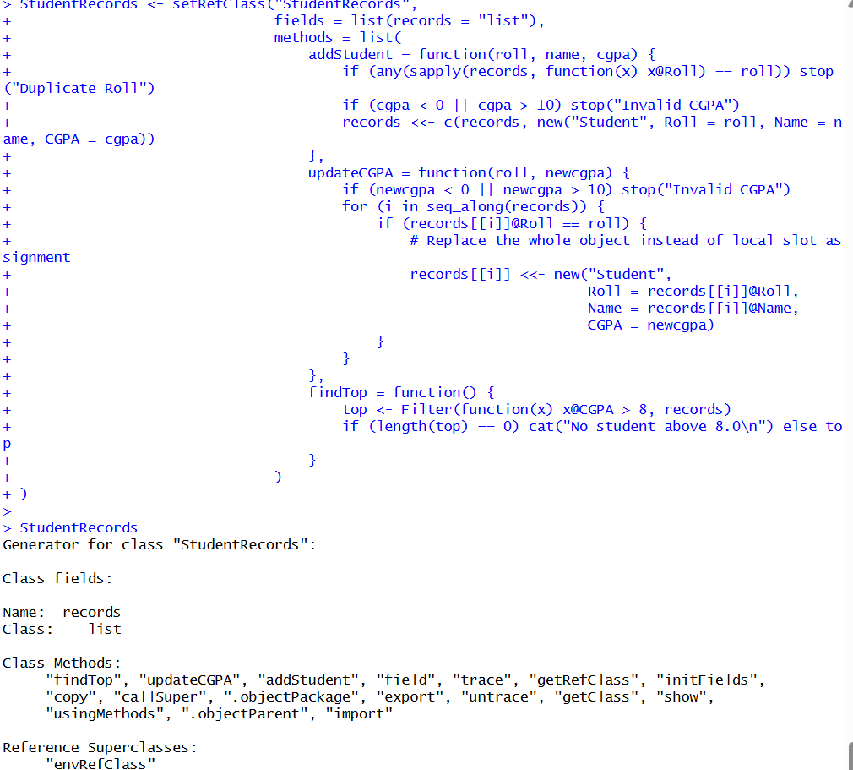

RUBRICS FOR CALCULATION:

Criteria | Weightage | Level 4 – Exemplary | Level 3 – Proficient | Level 2 – Developing | Level 1 – Beginning
Understanding of Problem Context | 20 | Clearly understands the problem and accurately identifies all requirements | Good understanding with minor gaps | Basic understanding; some requirements unclear | Poor understanding or misinterpretation of the problem
Application of Concepts | 30 | Accurately applies appropriate concepts to solve complex problems | Applies relevant concepts correctly with minor errors | Applies basic concepts with limited accuracy | Fails to apply appropriate concepts
Problem-Solving Approach | 20 | Logical, well-structured, and efficient approach | Mostly logical approach with minor gaps | Basic approach with some inconsistencies | Illogical or unclear approach
Accuracy of Solution | 20 | Completely correct solution with proper justification | Mostly correct with minor errors | Partially correct solution | Incorrect or incomplete solution
Clarity | 10 | Clear, well-organized, and properly explained solution | Understandable with minor clarity issues | Limited clarity and explanation | Poorly presented and difficult to understand

